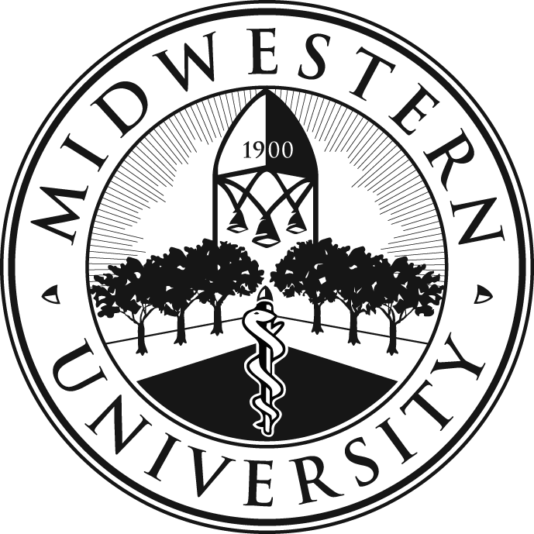

The Midwestern University

Community Health Lecture Series 2024

The Midwestern University Community Health Lecture Series offers FREE monthly public lectures on health and medicine by Midwestern University faculty. All lectures take place from 6:30-7:30 pm at the Glendale-Foothills Branch Library, 19055 North 57th Avenue in Glendale. For more information, please call 623/930-3868. Reservations are not necessary. To receive a monthly email about these health lectures, please send an email to azevents@midwestern.edu.

The information presented in these lectures is provided for informational purposes only and is not for use in diagnosing any condition. The information is not intended to be a substitute for professional medical advice, diagnosis, care, or treatment. Always consult your physician or other qualified healthcare provider with any questions regarding any possible medical condition.

Monday, July 8, 2024, 6:30 PM to 7:30 PM
The Importance of Early Pediatric and Orthodontic Dental Treatment
Presented by Karen Berrigan, D.M.D., and Sabita Rao, D.M.D., Clinical Assistant Professors, Dental Institute, Midwestern University College of Dental Medicine-Arizona

Join Dr. Berrigan and Dr. Rao as they discuss the importance of early dental treatment. In this lecture, they will describe specific ages when dental treatment will benefit a child, what to expect with early treatment, and why early treatment is beneficial.

Monday, August 12, 2024, 6:30 PM to 7:30 PM
Diabetes Basics
Presented by Gwen Wodiuk, D.N.P., FNP, Clinical Assistant Professor, Midwestern University Arizona College of Osteopathic Medicine

Join Dr. Wodiuk for a foundational discussion of diabetes, a common condition that affects more than 29 million Americans. She will explain how diabetes affects the body and how to manage it in a healthy way, as well as specifics on how diabetes is diagnosed, such as measuring fasting glucose and hemoglobin A1C. Dr. Wodiuk will also address living with diabetes, including lifestyle changes and medication that can help manage symptoms.

Monday, September 9, 2024, 6:30 PM to 7:30 PM
Breast Health, Self-Exams, and Lymphedema
Presented by Rita Ator, PT, D.P.T., OCS, Assistant Professor, Physical Therapy, Midwestern University College of Health Sciences

Join Dr. Ator for a discussion on how to maintain good breast health, optimal ways to conduct self-exams, and the realities of lymphedema. Dr. Ator will also share details about how often breast cancer occurs, how to prevent and detect lymphedema, and what type of treatments are available.

Monday, October 21, 2024, 6:30 PM to 7:30 PM
The Aging Eye: What is Normal and What is Not?
Presented by Pierce Kenworthy, O.D., FAAO, Associate Professor, Eye Institute, Midwestern University Arizona College of Optometry

Join Dr. Kenworthy for an overview of what to expect from our eyes as we age. In this discussion, he will describe common eye diagnoses and procedures such as dry eye, cataract surgery, and intraocular lens options. Management of these common conditions and other age-related eye changes will also be discussed.

Monday, November 11, 2024, 6:30 PM to 7:30 PM
Older Adult Oral Health
Presented by Anita Chu Fountain, D.D.S., Clinical Associate Professor, and Denise Mills, D.D.S., M.H.A., Ed.D., Clinical Professor, Dental Institute, Midwestern University College of Dental Medicine-Arizona

Did you know one out of five older adults have lost all of their teeth or have untreated tooth decay, and two out of five have gum disease? Join Dr. Chu and Dr. Mills as they discuss oral health problems for adults over 65, including why oral and pharyngeal cancers are primarily diagnosed in older adults, and why ER visits have increased in recent years due to the effects of marijuana use on oral health.

